CASE FILE 10
Shine Club Car Wash
Product line: car wash memberships
Shine Club is a car wash on Rand Road that wants to switch from single washes to monthly memberships. Different drivers want very different things from a car wash.
Your job: Build a lineup of three versions, one for each segment below. For every version, choose its features and set its price. Your goal is the most total profit across all three.
THE MARKET: THREE SEGMENTS
Shine Club Car Wash surveyed people in the Chicago area. The survey split them into three groups. Read the profiles, then give each segment a name.
SEGMENT A  7,000 potential customers | SEGMENT B  3,000 potential customers | SEGMENT C  9,000 potential customers
- Ages 16 to 22, just got their first car  - Washes it before school events and weekends  - Paying with money from a part-time job  “My car is basically my personality.” | - Rideshare and delivery drivers  - Drives 40 or more hours a week  - Customer ratings depend on a clean car  “A dirty car costs me stars.” | - Parents with 2 or more cars in the household  - Fights road salt every winter  - Car is full of sports gear and snack crumbs  “Between soccer cleats and road salt, the van is a disaster.”
Our name for them: | Our name for them: | Our name for them:
PRODUCT BASICS
Base cost of every version | $5 per member per month, before any features are added
Price options | $10 $15 $22 $30 $40 $55 (each version must use one of these prices)
WARM-UP: READ THE DATA FIRST
1. Which segment has the most must-have features (60% or higher)? How many does it have?

2. What is the most expensive feature on the menu? Which segment, if any, says it is a must-have?

3. What is the lowest price at which fewer than half of Segment B would buy?

4. If Shine Club Car Wash sold a version with a Fit of 100% to Segment A at $15, how many people would buy it?

SURVEY RESULTS: WHAT EACH SEGMENT REQUIRES
Question asked: “Which of these would a car wash membership need to have before you would buy it?”
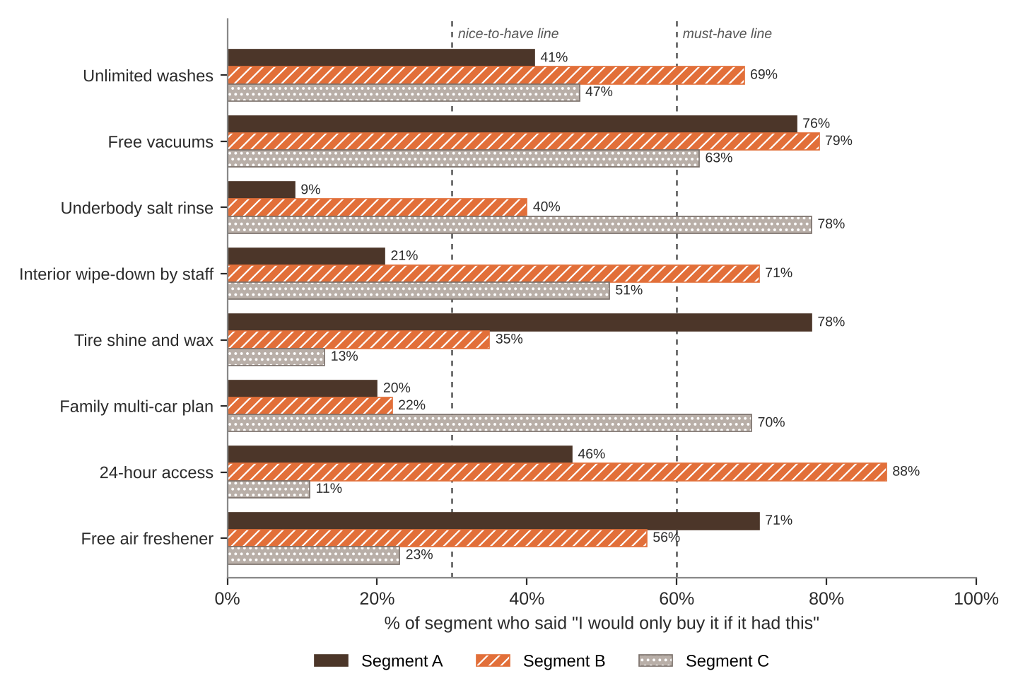
FEATURE MENU
Every feature you add raises your cost per member per month. Add a feature to any version you want.
Feature | What it is | Cost to add
Unlimited washes | Wash as often as you want | $6
Free vacuums | Self-serve vacuum stations | $1
Underbody salt rinse | Blasts winter salt off the frame | $2
Interior wipe-down by staff | Dash, cupholders, and windows cleaned | $8
Tire shine and wax | Glossy finish on every wash | $3
Family multi-car plan | Add a second car at a discount | $5
24-hour access | Wash any time, day or night | $2
Free air freshener | Pick a scent each visit | $0.50
SURVEY RESULTS: WHAT EACH SEGMENT WILL PAY
Question asked: “If it had everything you need, would you buy it at this price?”
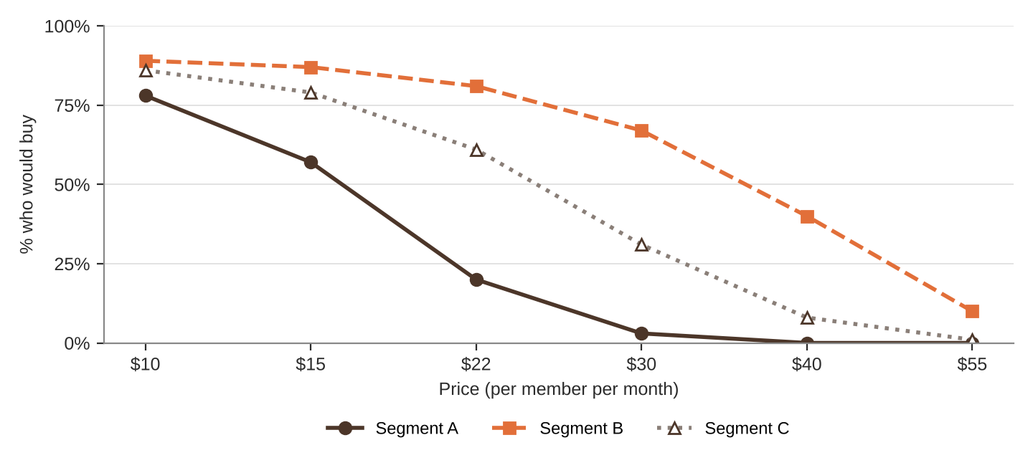
% of each segment who would buy at each price
Price | $10 | $15 | $22 | $30 | $40 | $55
Segment A | 78% | 57% | 20% | 3% | 0% | 0%
Segment B | 89% | 87% | 81% | 67% | 40% | 10%
Segment C | 86% | 79% | 61% | 31% | 8% | 1%
QUICK RULES
Must-have | A feature that 60% or more of a segment requires. Leave one out and that segment's buyers are cut in half. Leave two out and they're cut in half again.
Nice-to-have | A feature that 30% to 59% of a segment requires. Each one you include adds 5% to Fit.
Under 30% | That segment doesn't care. It adds cost and nothing else.
Fit | Start at 100%. Add 5% for each nice-to-have included. Then cut in half for each must-have left out.
Buyers | Segment size × % who would buy at your price × Fit. Round to a whole number.
Profit | Buyers × (Price − Unit cost). Unit cost = base cost + cost of every feature you added.

